**Sassy 活泼的**

**Give sb a slap**

**Give him a slap on the back**

**Slap sb across one’s face**

**Scold 斥责 骂**

**Oh my god ..**

**Oh my gosh..**

**Diversity**

**Political correctness**

**Politically correct..**

**Cancel**

**Swipe the phone..**

**Peek at ..**

**Because she’s a pain -**

**A pain in the neck /**

**Time-out**

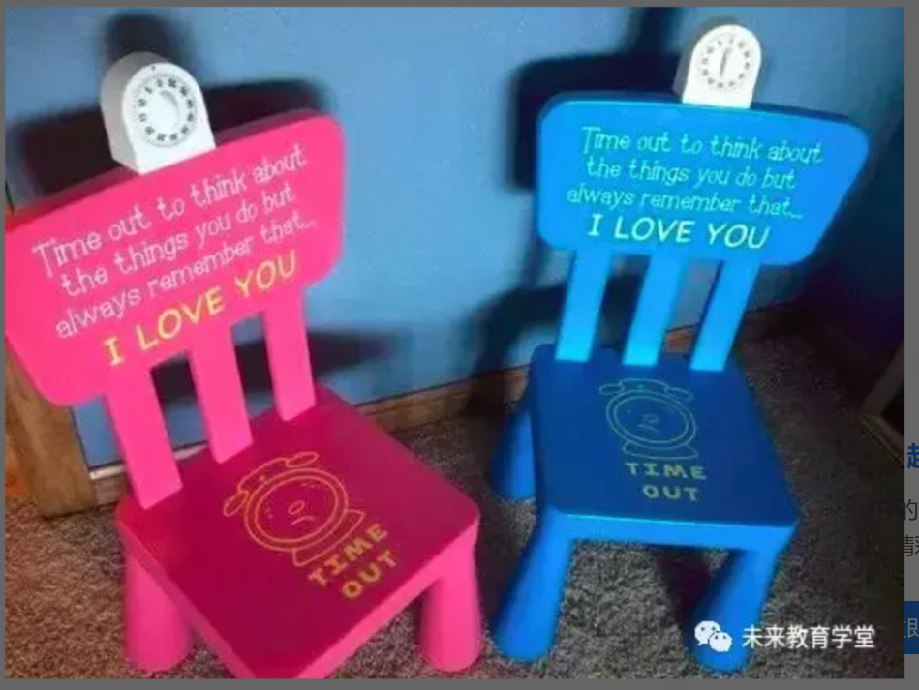

**Get disciplined**

**Get things taken away**

**Privilege**

**Action Figure**

**Philosophy phil soph**

**Phile philia phil 喜爱 偏好**

**Ped ① 脚 ② 小孩 pedophile 恋童癖者 pedophilia 恋童癖**

**Phobe phobia 害怕 恐惧 homophobe 恐同者**

**Hydrophobia hydro 水**

**Sob**

**Shed tears**

**Heroes shed no tears**

**Y**

**Caky**

**Vacuuming vacuum 真空 vacuum cleaner 吸尘器**

**Feed the dogs**

**Mow the grass**

**Overhear**

**Fight against sb**

**If I remember correctly ..**

**If my memory serves me right…**

**It happened when I was like seven years old…**

**Be in the mood for ..**

**Suddenly I was in the mood for a fight..**

**I fire the blanket…**

**Lighter light lit**

**Lecture sb about sth**

**ie one of such a kind cutie softie**

**spank**

**pinch**

**pop**

**scold 斥责**